Papa Corey_CMFS150M__FCS
Coriolis Flowmeter Calculation Summary |  |  |  |  |  | Quote/Rev No: |  |  |  | -/-
Date: |  |  |  | ‭2023-03-30‬
Company: |  |  |  | -
Project Name: |  |  |  | -
Service: |  |  |  | -
Sensor Model Name : |  |  |  | CMFS150M
Sensor Model #: |  |  |  | -
Sizing Name: |  |  |  | Papa Corey
Transmitter Model Name : |  |  |  | -
Transmitter Model #: |  |  |  | -
Transmitter Tag(s): |  |  |  | -
Wetted Material: |  |  |  | 316L
Fluid: |  |  |  | GULF COAST NATURAL GAS
Fluid State: |  |  |  | Gas
K(Flow Consistency Index) |  |  |  | -
n(Flow Behavior) |  |  |  | -
Mass Flow Accuracy (+/- % of Rate) |  |  |  | 0.2715
Pressure Drop at Operating Flow |  |  |  | 0.2165 | psig
Velocity at Operating Flow |  |  |  | 16.3778 | m/sec
 |  |  |  | Min | Operating* |  |  | Max |  |  | Design |  | Units
Flow Rate: |  |  |  | 30.0000 | 300.0000 |  |  | 350.0000 |  |  | - |  | kg/hr
Pressure: |  |  |  | - | 150.0000 |  |  | - |  |  | - |  | psig
Process Fluid Temperature: |  |  |  | - | 50.0000 |  |  | - |  |  | - |  | F
Ambient Temperature: |  |  |  | - | 68.0000 |  |  | - |  |  | - |  | F
Density: |  |  |  | - | 0.5192 |  |  | - |  |  | 0.0000 |  | lb/ft3
Viscosity: |  |  |  | - | 0.0103 |  |  | - |  |  | - |  | cP
Gas Only | Base Reference Temperature: |  | F | 60.0000
Gas Only | Base Reference Pressure: |  | psia | 14.6960
Gas Only | Base Reference Density: |  | lb/ft3 | 0.0440
Process Connection: |  |  |  | -
Process Connection Pressure Rating: |  |  |  | -
@Temperature: |  |  |  | 50.0000 F
Flow Rate | kg/hr | Mass Flow Accuracy (+/- % of Rate) |  | Pressure Drop* | psig |  | Velocity at Operating Flow |  | m/sec |  |  | Re
350.0000 |  | 00.2500 |  | 0.2917 |  |  | 19.1075 |  |  |  |  | 305415.4685
318.0000 |  | 0.2562 |  | 0.2423 |  |  | 17.3605 |  |  |  |  | 277491.7685
286.0000 |  | 0.2848 |  | 0.1974 |  |  | 15.6135 |  |  |  |  | 249568.0685
254.0000 |  | 0.3207 |  | 0.1570 |  |  | 13.8666 |  |  |  |  | 221644.3685
222.0000 |  | 0.3669 |  | 0.1212 |  |  | 12.1196 |  |  |  |  | 193720.6686
190.0000 |  | 0.4287 |  | 0.0900 |  |  | 10.3726 |  |  |  |  | 165796.9686
158.0000 |  | 0.5155 |  | 0.0635 |  |  | 8.6257 |  |  |  |  | 137873.2686
126.0000 |  | 0.6465 |  | 0.0417 |  |  | 6.8787 |  |  |  |  | 109949.5686
94.0000 |  | 0.8666 |  | 0.0246 |  |  | 5.1317 |  |  |  |  | 82025.8687
62.0000 |  | 1.3138 |  | 0.0120 |  |  | 3.3847 |  |  |  |  | 54102.1687
30.0000 |  | 2.7152 |  | 0.0036 |  |  | 1.6378 |  |  |  |  | 26178.4687
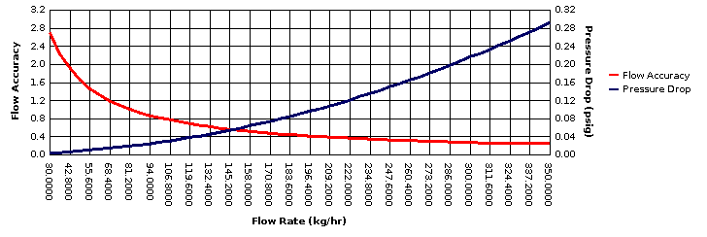
* All pressure drop and velocity results are based on the process conditions (except flow rate) that are entered in the Operating column.

